

Activity 3.1.1 Time Series and Trends

Introduction

|  |  |
| --- | --- |
| Think of something you have observed changing. It could be a plume of smoke from a car or a campfire, winding upward; it could be the sounds of the city or the birds waking up in the morning. As things change over time, patterns emerge. Creating **visualizations** of data can help reveal those trends. A data visualization is any graphical representation of a data set.  Time can be represented in several ways, including:  • Plotting time as the x-coordinate in a scatter plot or line graph.  • Animating any type of data visualization, with each frame visualizing data from one point in time.  Have you ever seen a representation of your height as you got older? Did it fit in one of these two categories? | backgrounds,businesses,continents,countries,Earth,Fotolia,geography,global,globes,hands,holding,maps,Photographs,planets,protects,safety,spheres,universes,wallpapers,worlds Image ©Microsoft |

Materials

• Computer with Enthought Canopy distribution of *Python®* programming language, Flash, and access to Internet

• 3.1.1 SourceFiles containing 7Mb yobYYYY.txt data and visualize_names.py

• 3.1.1 OptionalSourceFiles containing 23Mb state-level data (optional)

Procedure

In this activity you will explore two data sets that represent values that change over time.

1. Form pairs as directed by your teacher. Meet or greet each other to practice professional skills. Set team norms.

**Part I: Name Frequencies**

2. Using Notepad++, open the data file corresponding to your year of birth in the SourceFiles folder. Select **Search** > **Find** and find your name.

a. How many babies of each gender in your year of birth were given the same name as you?

F, 12

b. Look up another name as similar to yours as possible – maybe a variation in spelling or a common nickname. How many babies of each gender in your year of birth were given that name?

M, 527

3. If directed by your teacher, use Notepad++ to open the data file corresponding to the state in which you were born, and find the line containing your name and your year of birth. Describe the algorithm you used for finding that line.

I just searched for the data file using the search function.

4. You are going to construct a graph showing the U.S.-wide popularity of your name, with popularity changing over time. How could you do this by hand? Describe the algorithm you would follow to gather the necessary data from all of the files if you were to do this without programming.

5. Computing changes how we deal with data because people with programming skills can automate time-consuming tasks.

Launch Canopy. Open an editor window and open the visualize_names.py program in the code editor. Execute the program. A plot should be produced. You might have to select the plot's icon in the taskbar.

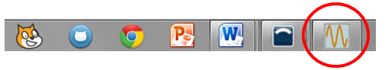

The plot shows the frequency of these names vs. time. The **frequency** of something tells how many times it occurred. Estimate how long it would have taken you to produce this time series plot by hand.

6. Read and discuss the code with your partner. In the code shown below, circle the first use of each variable, and identify the variable role (fixed value, most recent, stepper, walker, accumulator, aggregator, one-way flag, or best-so-far) for each variable. If a variable is used for different roles at different lines of code, note that too.

|  |  |
| --- | --- |
| 1  2  3  4  5  6  7  8  9  10  11  12  13  14  15  16  17  18  19  20  21  22  23  24  25  26  27  28  29  30  31  32  33  34  35  36  37  38  39  40 |  |

7. Reflect on how well the comments in the code assisted you in understanding why variables were being used and what they represented. Where are more comments needed?

The comments help by telling me what needs to be created in the code, line 36, 29-40.

8. Creating code to automate a task often takes as long as just doing the task by hand, especially if it is the first time you are using a library. Estimate how long it would take you as a pair to create this program, including the research you would have to do to find and learn from documentation. Describe how you arrived at your estimate.

I think that it would take us about 40 minutes because we would have to research it and then as we code it is almost a guarantee that we run into errors along the way so that should add time totaling at about 35-40 minutes.

9. One reason to automate tasks with a program is to make the task easy to do again after modifying it slightly. Estimate how much time you will need to create another data visualization from this data set, describing the pattern of baby name frequency vs. time for a different name.

I think it would take us about 15 minutes to create another data visualization set because we could just use the code and documentation from the previous problem to assist us.

10. Writing code to automate a task is worth the work if you will need to repeat the task a certain number of times or more. Based on your answers to Steps 5, 8, and 9, how many visualizations of the names data would make the effort to write this program worthwhile?

About 6

11. Modify the code to visualize the pattern of data for your name and a variation of your name as described in Step 2. Repeat with your partner's name and a variation on that name. Paste screenshots of the two data visualizations here.

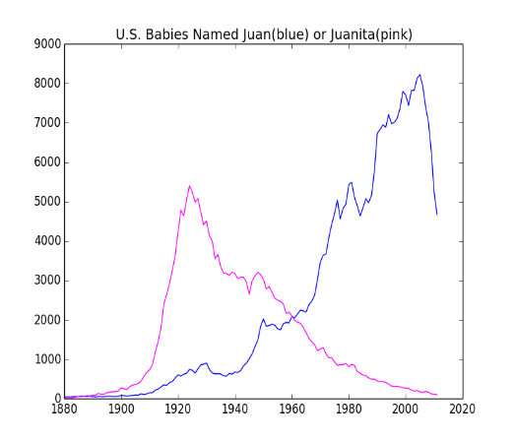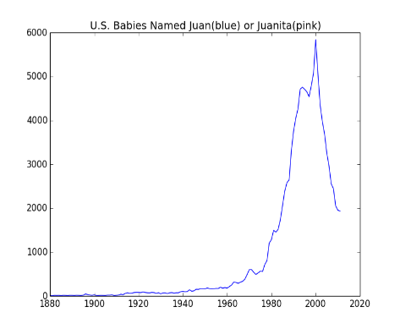

12. Describe the trends you observe and the knowledge you gained about the data

you visualized. How do the names compare? When was the peak frequency? Were there periods of time with especially high rates of increasing or decreasing frequency for these names?

One name was popular then declined around 2000, 2000, high rates

13. Using computational power to analyze data is most powerful if the analysis can be **generalized**. A solution is generalized if it can be applied to solve related problems or answer related questions. One way to generalize a solution is to avoid hard-coding values in your code, or at least to use fixed-value variables when you hard code a value. **Hard coding** arguments in your program makes your code less flexible.

a. It is best if hard-coded data is kept in a single place in the program. Line 39 of the code has hard-coded data. What are the disadvantages of this?

b. Change line 39 so that it relies on the fixed-value variables that were assigned at the beginning of the program.

14. The program could be made more flexible if other lines in the program used fixed-value variables. Which variables could be created to improve this program? List them. For each one identify:

• The line number of code where data is currently hard coded.

• The name of the variable you would use instead.

• The code you would place at the top of the program to initialize this variable.

15. What are some questions you could answer from these data sets using computational power that you would not be able to answer in a reasonable amount of time without writing code? Brainstorm as a class.

16. These data files contain the frequency of each name. The frequency is the number of times the name occurred. You might be more interested in what percentage of the people born each year were given a particular name. These percentages would be an example of relative frequencies. **Relative frequency** is the frequency of something (like a name) as a portion of (divided by) the total. The relative frequencies add up to 100% for each year.

1. Describe an algorithm that could be used to create a data file of relative frequencies from a data file of frequencies.
2. Algorithms can be described using a natural (human) language, pseudocode, flow diagrams, or a computer language. Which type of description did you use in Step 16a, and why?
3. In Microsoft Excel®, open the file containing data for your birth year. Since it is a CSV file instead of an XLSX file, you will have to select **All Files** in the Open File dialog box as shown on the left below. In the Import Wizard, include **Comma** in the **delimiters** as shown on the right below.

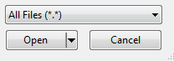 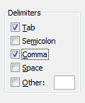

1. Calculate the relative frequency of the names with the following steps.
2. Use the scrollbar to find the first and last names of your gender. In an empty cell in column E, create a formula for the total of all people of your gender as shown below. Use the formula =sum(*first_cell*:*last_cell*). To enter this colon-separated range, you can select the range with your mouse while editing the formula. For a large range like this, select a cell at one end of the range, use the scroll bar to move to the other end of the range, and then use shift-click to select the cell at the other end of the range. Once you have selected the range, you can press enter to accept the formula.

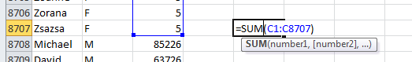

1. Take note of the cell containing the sum you just created. Create a formula for the relative frequency of the first name, =*cellWithAbsoluteFrequency*/*cellWithSum*. An example is shown below.

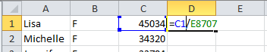

1. Change the formula you just created so that the reference to the sum has an **absolute reference** for the row. An absolute reference to a row or column will continue to refer to the same row or column when copied to another cell. You can create an absolute reference in Excel by inserting a $ before the row or column number. For example, =C1/E$8707 will continue to refer to row 8707 when copied.
2. Use the fill tool to copy the formula to all the other rows for your gender. For a small spreadsheet, you can drag the fill anchor as shown below.

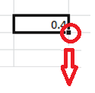

For a larger spreadsheet like this one, select a range to fill, including the cell from which you want to copy. You can use the select-scrollbar-shiftclick method from step i above. Then select the fill tool from the ribbon, as shown below.

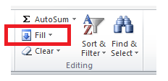

1. Use Ctrl-f to find your name in the spreadsheet. What percent of males or females born in your birth year were given your name?

17. The baby naming data are from the Social Security Administration. They provide interactive web pages that let you query a single name against a limited database, and they also provide static web pages offering download of the full data set in the compressed files you received, provided at <http://www.ssa.gov/OACT/babynames/limits.html>. The page with the zipped data files says, "To maintain an acceptable performance level on our servers, we provide only the top 1000 names through [our forms](http://www.ssa.gov/OACT/babynames/index.html#t0=2)." Explain – in terms of CPU operations – why using only the most common 1000 names makes their web pages load more quickly.

**Part II: Country Data**

18. Navigate to <http://gapminder.org> and load Gap Minder World. Click the play button and observe.

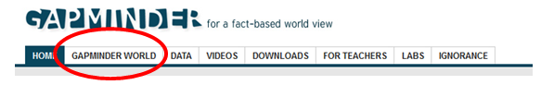

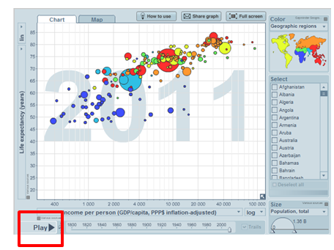

19. Notice that the visualization is displaying five variables. What does each of the following represent?

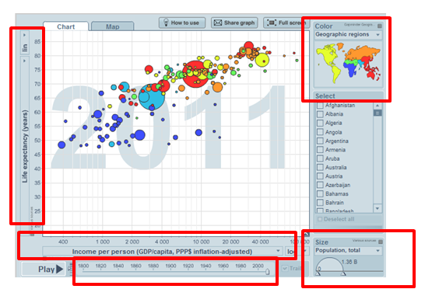

• x-coordinate of a dot:

• y-coordinate of a dot:

• radius of a dot:

• color of a dot:

• motion of a dot while the animation is playing:

20. Describe one general pattern that you observe.

21. Describe one **anomaly** that you observe. An anomaly is a data point or single pattern in a data set that does not follow the general pattern of the data set.

22. Choose new variables for the x-axis and y-axis using the dropdown menus on the x- and y-axis labels. Click play again, and identify a few countries that do interesting things when the graph is animated. You may also choose to identify countries of special interest to you. Not all countries report data for all variables in all years, so depending on what variables you select, you might not see much data.

23. Prepare written sentences that explain the visualization you created. Create a slide show that annotates the animation using a few screenshots. Include your commentary as text alongside the static graphics**.**

24. The baby names data contained five variables: name, gender, geographic state, time, and frequency. The line graph represented time on the x-axis and frequency on the y-axis. Each visualization represented one or two single values of name and gender and a single sum across all states.

To extract knowledge from data with a lot of variables, we have to be creative in how we represent data. Consider a visualization of the data set in Part II that would use a time series line graph like those created in Part I. Sketch an example of how that might look.

25. Compare the visualizations in Part I and Part II. Which type of visualization was better? For what types of data sets would you use a plot with time on the x-axis? For what types of data sets would you use an animation to represent time?

Conclusion

1. Computers already are better than humans at some aspects of data analysis. Humans continue to be better than computers at other aspects of data analysis. In both Parts I and II, you used a computer to create a visualization but used your brain to identify patterns in the data. Data visualization combines the strengths of humans and computers. What part of the discovery of knowledge in data are computers better at? What part of the discovery of knowledge in data are humans better at? Why?

2. Why are algorithms helpful when dealing with large data sets?

3. Look for a visualization of data that represents time as part of the visualization. Paste a copy of the visualization here. Describe what you think are strengths and weaknesses of the visualization. What were some good creative decisions made by the authors of the visualization, and what could they have done better? Are there any indications that the visualization does not correctly represent the data?